function ListofPlayers({ players }) {

  return (

    <div>

      {players.map((item, index) => (

        <li key={index}>

          Mr. {item.name} <span>{item.score}</span>

        </li>

      ))}

    </div>

  );

}

export default ListofPlayers;

function Scorebelow70({ players }) {

  let players70 = [];

  players.map((item) => {

    if (item.score <= 70) {

      players70.push(item);

    }

    return null;

  });

  return (

    <div>

      {players70.map((item, index) => (

        <li key={index}>

          Mr. {item.name} <span>{item.score}</span>

        </li>

      ))}

    </div>

  );

}

export default Scorebelow70;

export function OddPlayers([first, , third, , fifth]) {

  return (

    <div>

      <li> First : {first} </li>

      <li> Third : {third} </li>

      <li> Fifth : {fifth}</li>

    </div>

  );

}

export function EvenPlayers([, second, , fourth, , sixth]) {

  return (

    <div>

      <li> Second : {second} </li>

      <li> Fourth : {fourth} </li>

      <li> Sixth : {sixth}</li>

    </div>

  );

}

function ListofIndianPlayers({ IndianPlayers }) {

  return (

    <div>

      {IndianPlayers.map((player, index) => (

        <li key={index}>Mr. {player}</li>

      ))}

    </div>

  );

}

export default ListofIndianPlayers;

const T20Players = ['First Player', 'Second Player', 'Third Player'];

const RanjiTrophyPlayers = ['Fourth Player', 'Fifth Player', 'Sixth Player'];

export const IndianPlayers = [...T20Players, ...RanjiTrophyPlayers];

import './App.css';

import ListofPlayers from './ListofPlayers';

import Scorebelow70 from './Scorebelow70';

import { OddPlayers } from './OddPlayers';

import { EvenPlayers } from './EvenPlayers';

import ListofIndianPlayers from './ListofIndianPlayers';

import { IndianPlayers } from './IndianPlayers';

function App() {

  var flag = true;

  const players = [

    { name: "Jack", score: 50 },

    { name: "Michael", score: 70 },

    { name: "John", score: 40 },

    { name: "Ann", score: 61 },

    { name: "Elisabeth", score: 61 },

    { name: "Sachin", score: 95 },

    { name: "Dhoni", score: 100 },

    { name: "Virat", score: 84 },

    { name: "Jadeja", score: 64 },

    { name: "Raina", score: 75 },

    { name: "Rohit", score: 80 }

  ];

  const IndianTeam = ['Sachin1', 'Dhoni2', 'Virat3', 'Rohit4', 'Yuvaraj5', 'Raina6'];

  if (flag === true) {

    return (

      <div>

        <h1> List of Players </h1>

        <ListofPlayers players={players} />

        <hr />

        <h1> List of Players having Scores Less than 70 </h1>

        <Scorebelow70 players={players} />

      </div>

    );

  } else {

    return (

      <div>

        <div>

          <h1> Indian Team </h1>

          <h1> Odd Players </h1>

          {OddPlayers(IndianTeam)}

          <hr />

          <h1> Even Players </h1>

          {EvenPlayers(IndianTeam)}

        </div>

        <hr />

        <div>

          <h1> List of Indian Players Merged: </h1>

          <ListofIndianPlayers IndianPlayers={IndianPlayers} />

        </div>

      </div>

    );

  }

}

export default App;

OUTPUT:

FLAG = TRUE

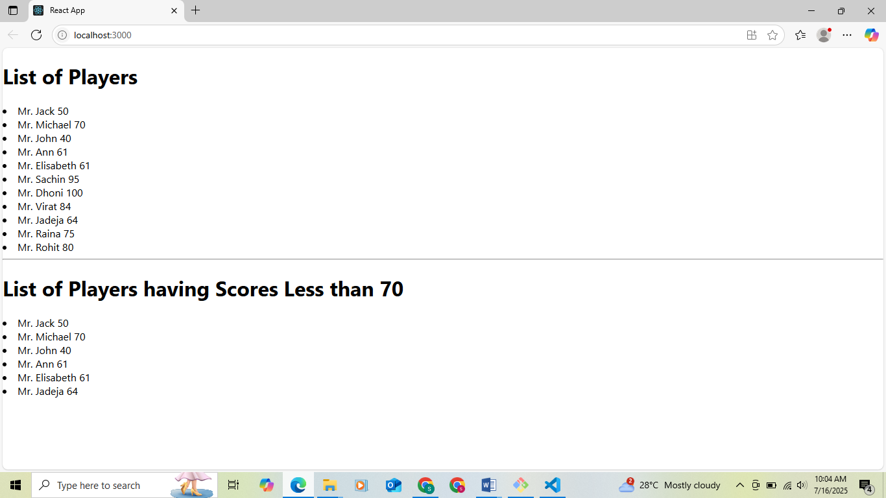

FLAG = FALSE

